ABC’s Inventory Management System

Test Script

Table of Contents

GRP001- Search The Known Transfer And View Its Details 3

Data Set 1 3

Data Set 2 5

Data Set 3 7

GRP002- Search The Unknown Transfer And View Its Details 9

Data Set 1 10

Data Set 2 11

Data Set 3 13

GRP003- Use Time Filter For Searching Report 14

Data Set 1 15

Data Set 2 17

Data Set 3 19

# GRP001- Search The Known Transfer And View Its Details

|  |  |  |  |  |  |
| --- | --- | --- | --- | --- | --- |
| **Test Name** | | Search The Known Transfer And View Its Details (Test Case GRP001) | | | |
| **Use Case Tested** | | Generate Report | | | |
| **Test Description** | | This test tests if the system can search the existing report by known transfer ID and view its details. | | | |
| **Pre-Conditions** | | Meta data must exist, product details like product item code, sending location ID and product quantity; transfer details like transfer date, transfer ID, description. | | | |
| **Post-Conditions** | | A list of products and product details for searching report will be displayed | | | |
| **Notes** | | This test assumes that the user knows the transferID. | | | |
| **Result (Pass/Fail/Warning/ Incomplete)** | | Pass | | | |
|  | **Test Step** | | **Expected Test Results** | **P** | **F** |
| 1. | Select Generate Report Button from home page | | Display the Generate Report page | P |  |
| 2. | Input known transfer ID in search field and click on the Search Button | | System display correct searched transfer | P |  |
| 3. | Click on the “View Product in this Transfer” button to check the products detail of this transfer | | System displays a list of products and its quantity | P |  |

## Data Set 1

|  |  |
| --- | --- |
| **Test Data Table** | |
| **transferID** | 3 |
| **From Date** | N/a |
| **To Date** | N/a |

#### Result Screenshots

The screenshots of the result on each test step for each data set are given below:

**Step 1**

Open the Generate Report Page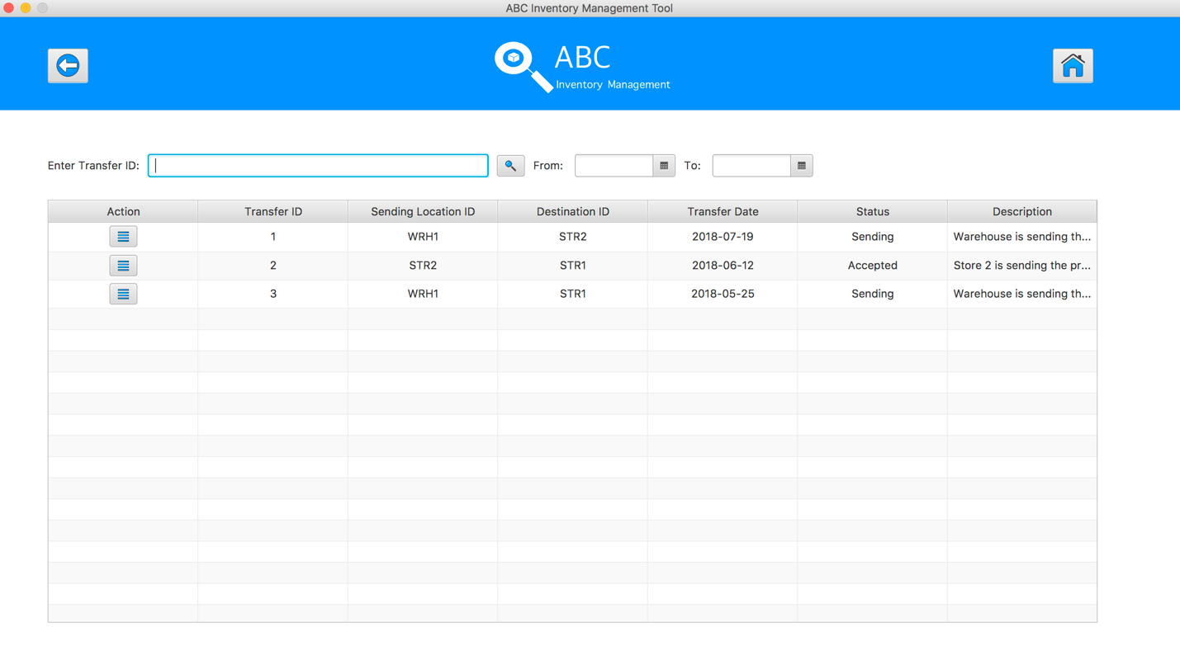

**Step 2**

Input transfer ID in search field and click on the Search Button

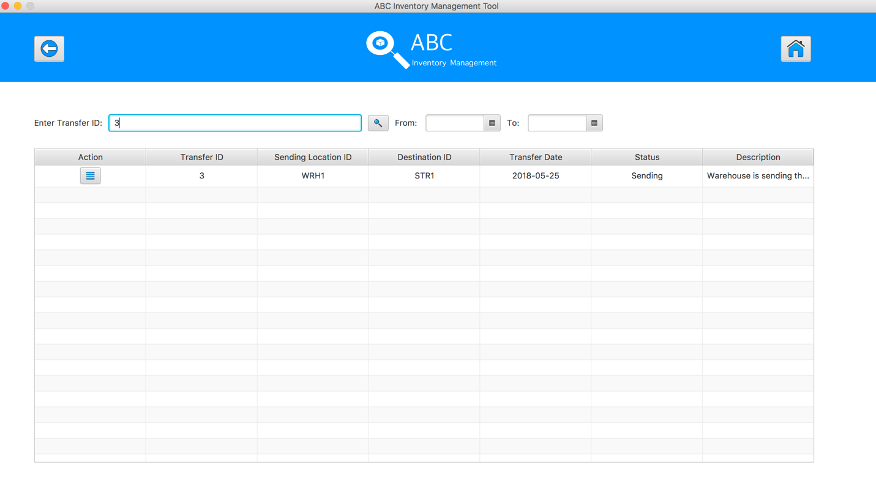

**Step 3**

Click on the “View Product in this Transfer” button, system display a list of product in selected transfer 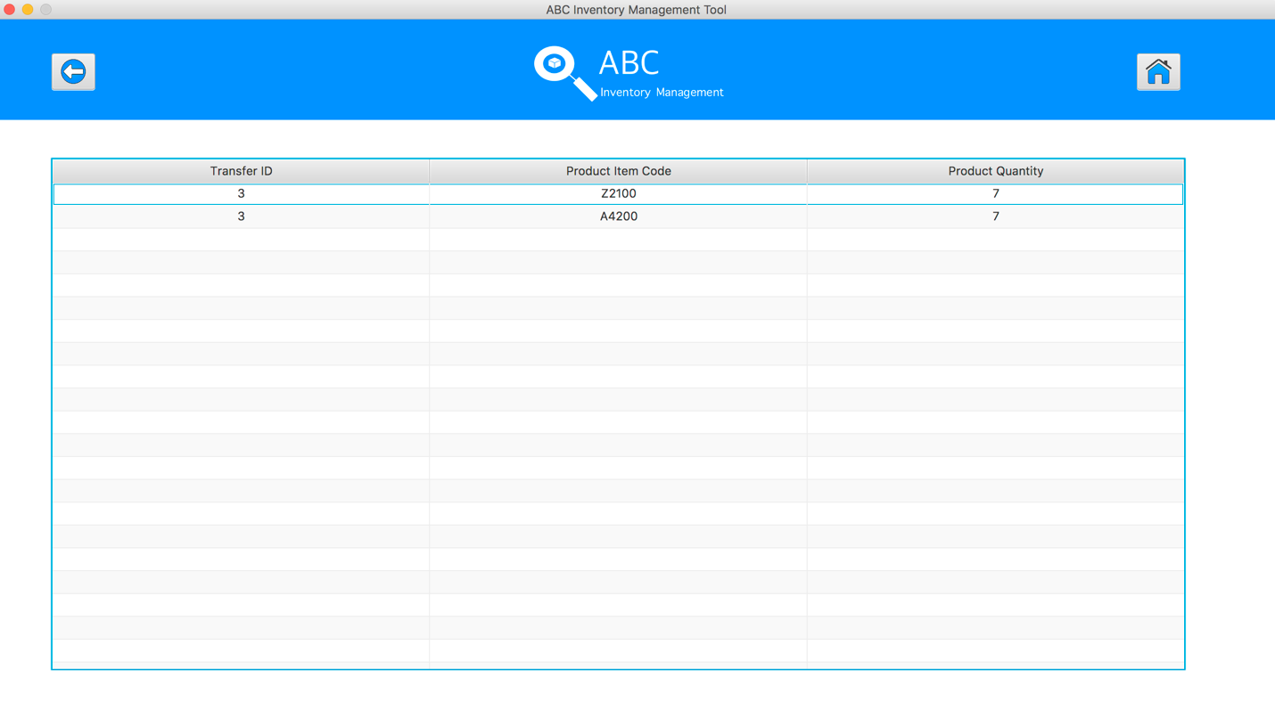

**GRP001- Test Search The Known Transfer And View Its Details** **for Data Set 1:** **PASS**

## Data Set 2

|  |  |
| --- | --- |
| **Test Data Table** | |
| **transferID** | 2 |
| **From Date** | N/a |
| **To Date** | N/a |

#### Result Screenshots

The screenshots of the result on each test step for each data set are given below:

**Step 1**

Open the Generate Report Page

**Step 2**

Input transfer ID in search field and click on the Search Button

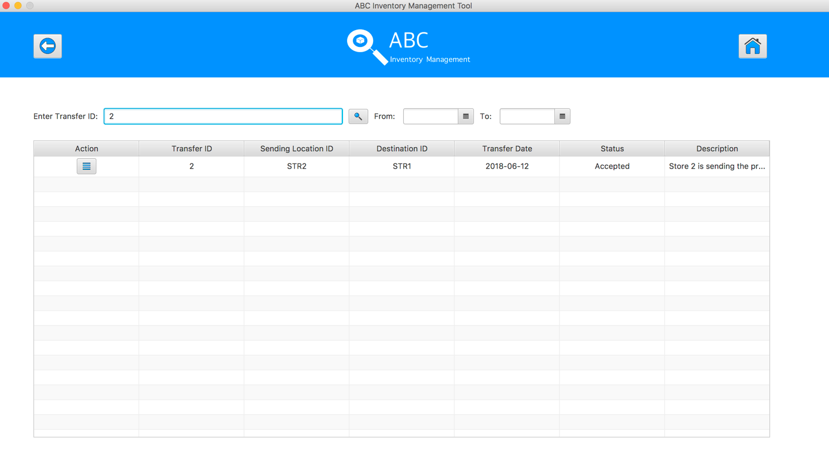

**Step 3**

Click on the “View Product in this Transfer” button, system display a list of product in selected transfer 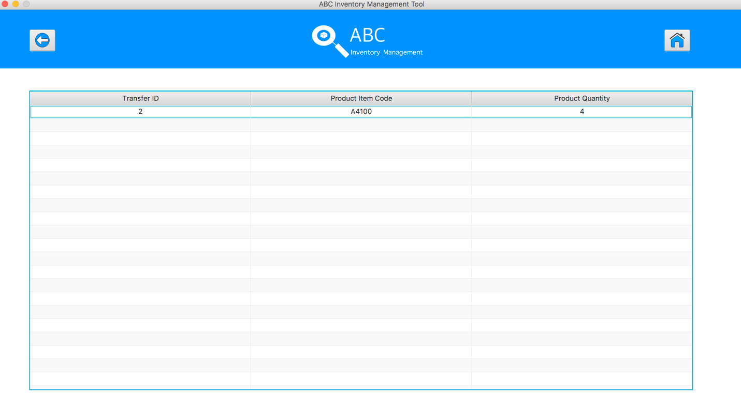

**GRP001- Test Search The Known Transfer And View Its Details** **for Data Set 2:** **PASS**

## Data Set 3

|  |  |
| --- | --- |
| **Test Data Table** | |
| **transferID** | 1 |
| **From Date** | N/a |
| **To Date** | N/a |

#### Result Screenshots

The screenshots of the result on each test step for each data set are given below:

**Step 1**

Open the Generate Report Page

**Step 2**

Input transfer ID in search field and click on the Search Button

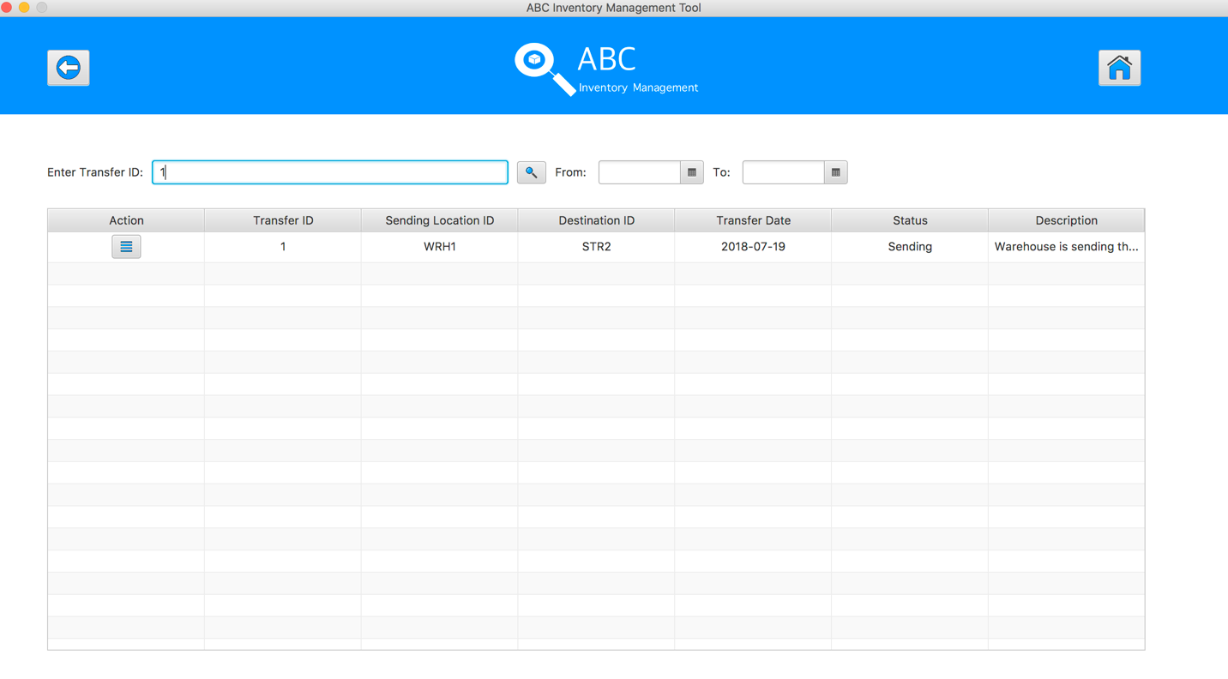

**Step 3**

Click on the “View Product in this Transfer” button, system display a list of product in selected transfer

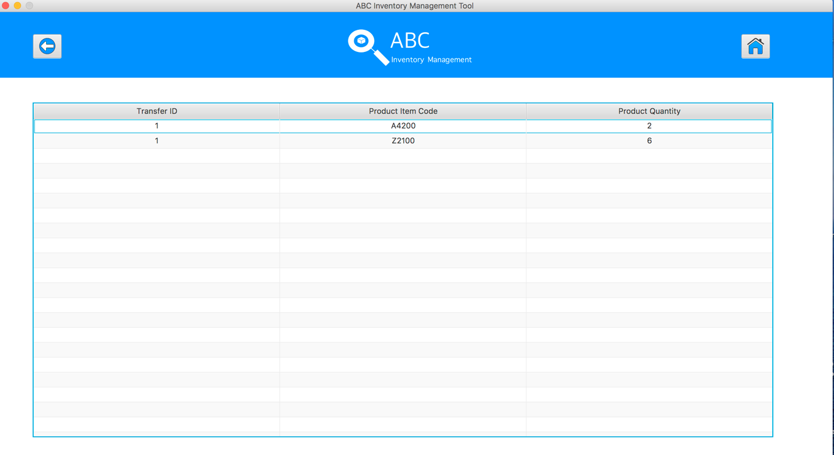

**GRP001- Test Search The Known Transfer And View Its Details for Data Set 3: PASS**

# GRP002- Search The Unknown Transfer And View Its Details

|  |  |  |  |  |  |
| --- | --- | --- | --- | --- | --- |
| **Test Name** | | Search The Unknown Transfer And View Its Details (Test Case GRP002) | | | |
| **Use Case Tested** | | Generate Report | | | |
| **Test Description** | | This test tests if the system can search the existing report by unknown transfer ID and view its details. | | | |
| **Pre-Conditions** | | Meta data must exist, product details like product item code, sending location ID and product quantity; transfer details like transfer date, transfer ID, description. | | | |
| **Post-Conditions** | | Appropriate alert message is displayed. | | | |
| **Notes** | | This test assumes that the user knows the transferID. | | | |
| **Result (Pass/Fail/Warning/ Incomplete)** | | Pass | | | |
|  | **Test Step** | | **Expected Test Results** | **P** | **F** |
| 1. | Select Generate Report Button from home page | | Display the Generate Report page |  |  |
| 2. | Input known transfer ID in search field and click on the Search Button | | System display correct searched transfer |  |  |
| 3. | Click on the “View Product in this Transfer” button to check the products detail of this transfer | | System displays a list of products and its quantity | P |  |

## Data Set 1

|  |  |
| --- | --- |
| **Test Data Table** | |
| **transferID** | 4 |
| **From Date** | N/a |
| **To Date** | N/a |

#### Result Screenshots

The screenshots of the result on each test step for each data set are given below:

**Step 1**

Open the Generate Report Page

**Step 2**

Input transfer ID in search field and click on the Search Button. An alert message will be displayed to notify user entered a wrong input.

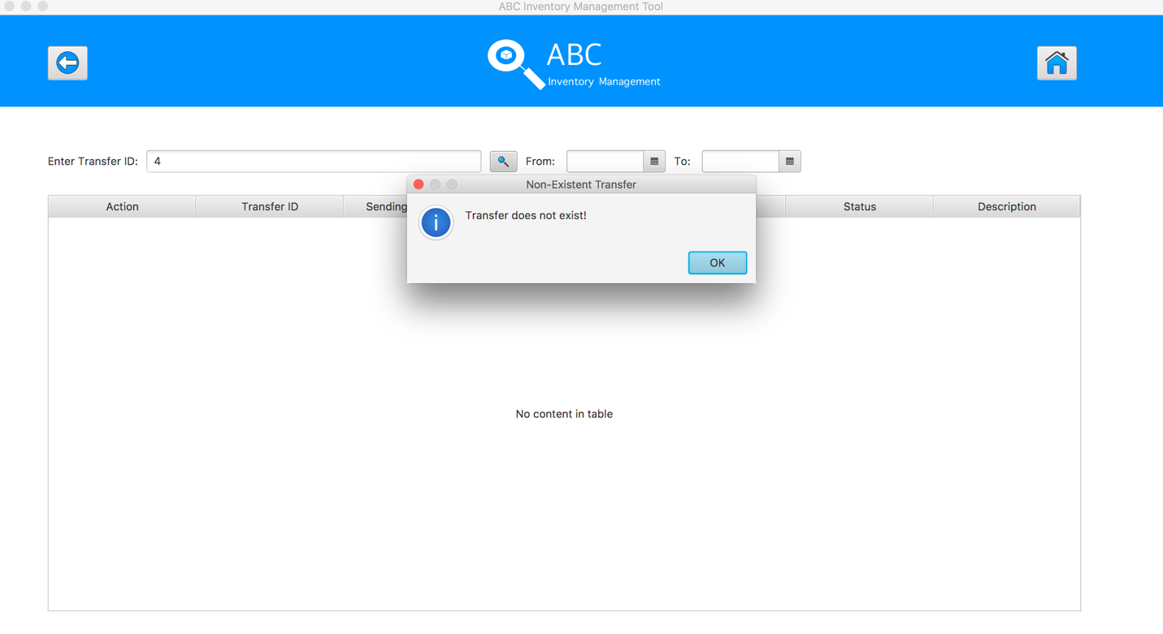

**GRP002- Test Search The Unknown Transfer And View Its Details for Data Set 1: PASS**

## Data Set 2

|  |  |
| --- | --- |
| **Test Data Table** | |
| **transferID** | SA |
| **From Date** | N/a |
| **To Date** | N/a |

#### Result Screenshots

The screenshots of the result on each test step for each data set are given below:

**Step 1**

Open the Generate Report Page

**Step 2**

Input transfer ID in search field and click on the Search Button. An alert message will be displayed to notify user entered a wrong input.

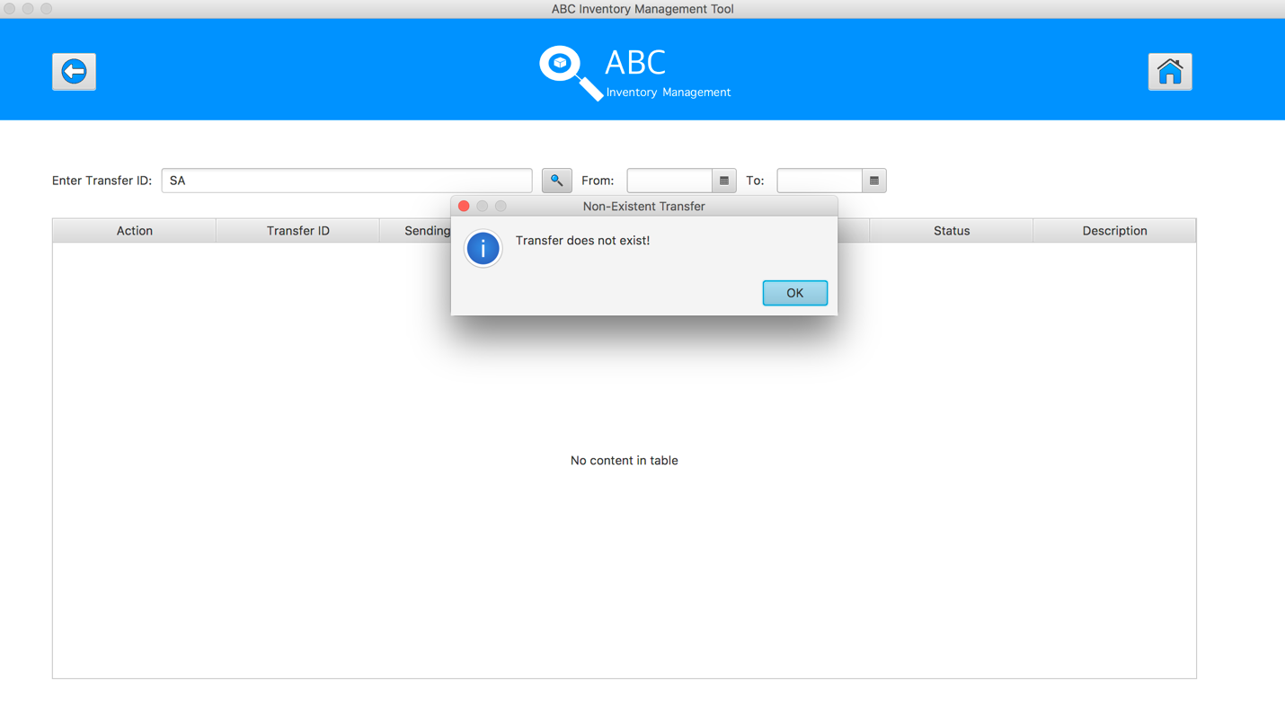

**GRP002- Test Search The Unknown Transfer And View Its Details for Data Set 2: PASS**

## Data Set 3

|  |  |
| --- | --- |
| **Test Data Table** | |
| **transferID** | -3 |
| **From Date** | N/a |
| **To Date** | N/a |

#### Result Screenshots

The screenshots of the result on each test step for each data set are given below:

**Step 1**

Open the Generate Report Page

**Step 2**

Input transfer ID in search field and click on the Search Button. An alert message will be displayed to notify user entered a wrong input.

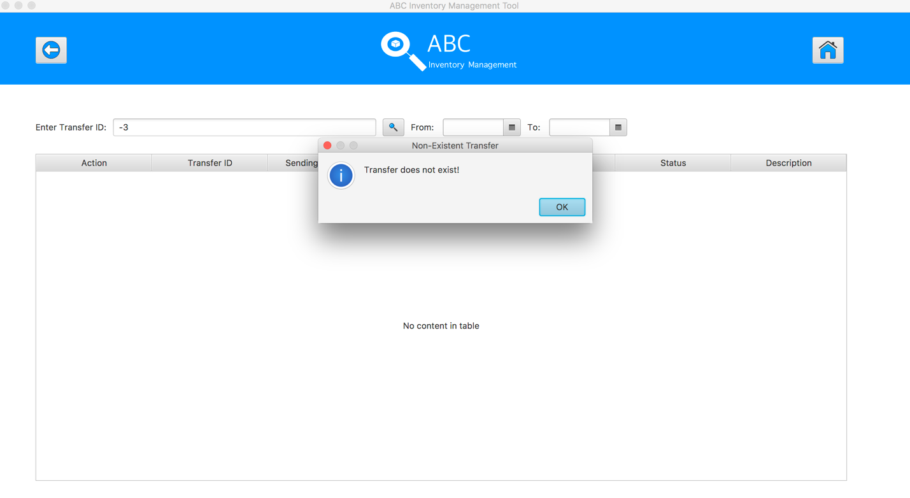

**GRP002- Test Search The Unknown Transfer And View Its Details for Data Set 3: PASS**

# GRP003- Use Time Filter For Searching Report

|  |  |  |  |  |  |
| --- | --- | --- | --- | --- | --- |
| **Test Name** | | Use Time Filter For Searching Report (Test Case GRP003) | | | |
| **Use Case Tested** | | Generate Report | | | |
| **Test Description** | | This test tests if the system can combine date filter for searching the existing report by known transfer ID and view its details. | | | |
| **Pre-Conditions** | | Meta data must exist, product details like product item code, sending location ID and product quantity; transfer details like transfer date, transfer ID, description. | | | |
| **Post-Conditions** | | A list of transfer will be display within searching timeframe, products and product details for searching report will be displayed | | | |
| **Notes** | | This test assumes that the user knows the transferID. | | | |
| **Result (Pass/Fail/Warning/ Incomplete)** | | Pass | | | |
|  | **Test Step** | | **Expected Test Results** | **P** | **F** |
| 1. | Select Generate Report Button from home page | | Display the Generate Report page |  |  |
| 2. | Choosing the From Date And To Date For Date Filter | | The datetime picker will be changed to the selected date | P |  |
| 3. | Input known transfer ID in search field and click on the Search Button | | System display correct searched transfer within the selected date | P |  |
| 4. | Click on the “View Product in this Transfer” button to check the products detail of this transfer | | System displays a list of products and its quantity | P |  |

## Data Set 1

|  |  |
| --- | --- |
| **Test Data Table** | |
| **transferID** | 3 |
| **From Date** | 24/05/2018 |
| **To Date** | 15/06/2018 |

#### Result Screenshots

The screenshots of the result on each test step for each data set are given below:

**Step 1**

Open the Generate Report Page

**Step 2**

Input From Date And To Date then hit search button to display the transfer in the selected timeframe

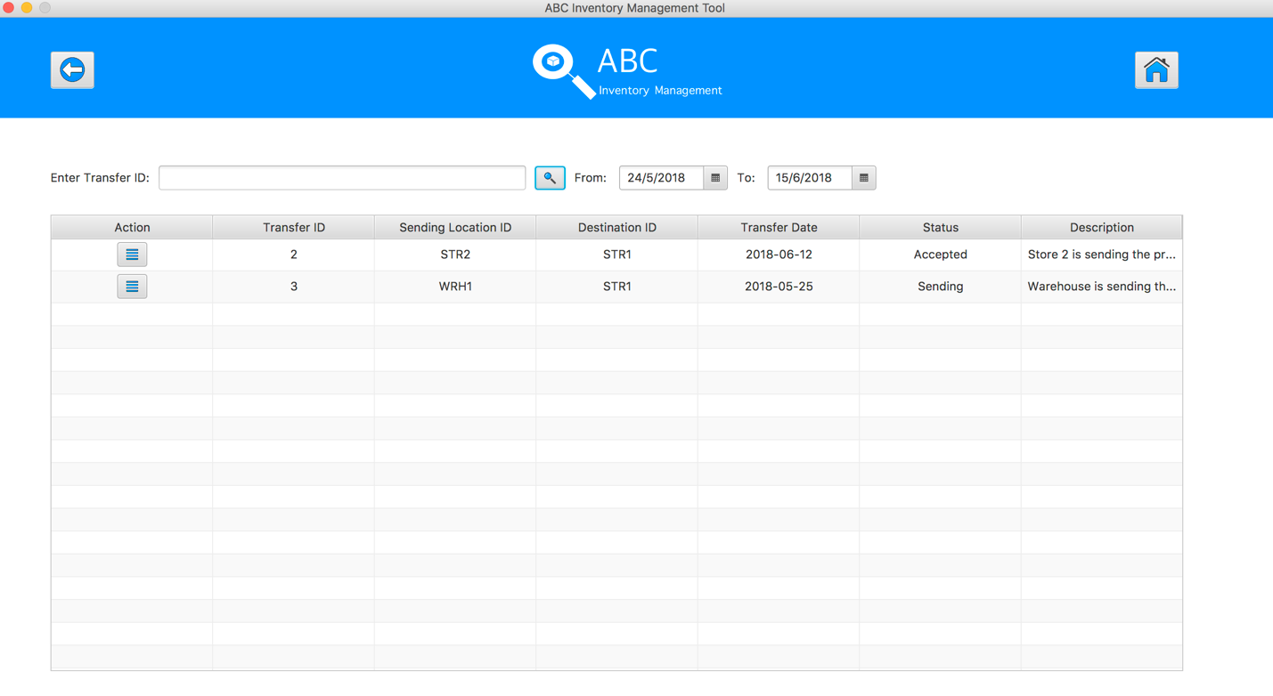

**Step 3**

Input the searching transfer ID then hit search button to get the transfer information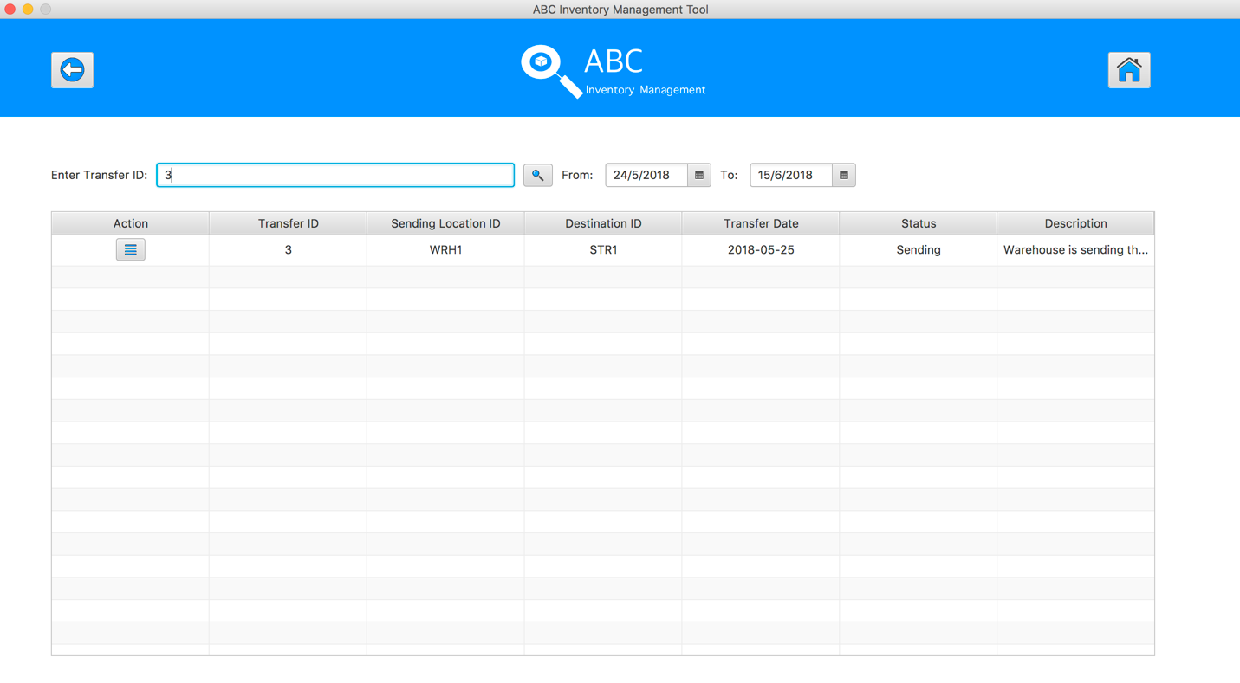

**Step 4**

Hit the ‘View the product in this transfer’ button to view the products and their quantity in this transfer.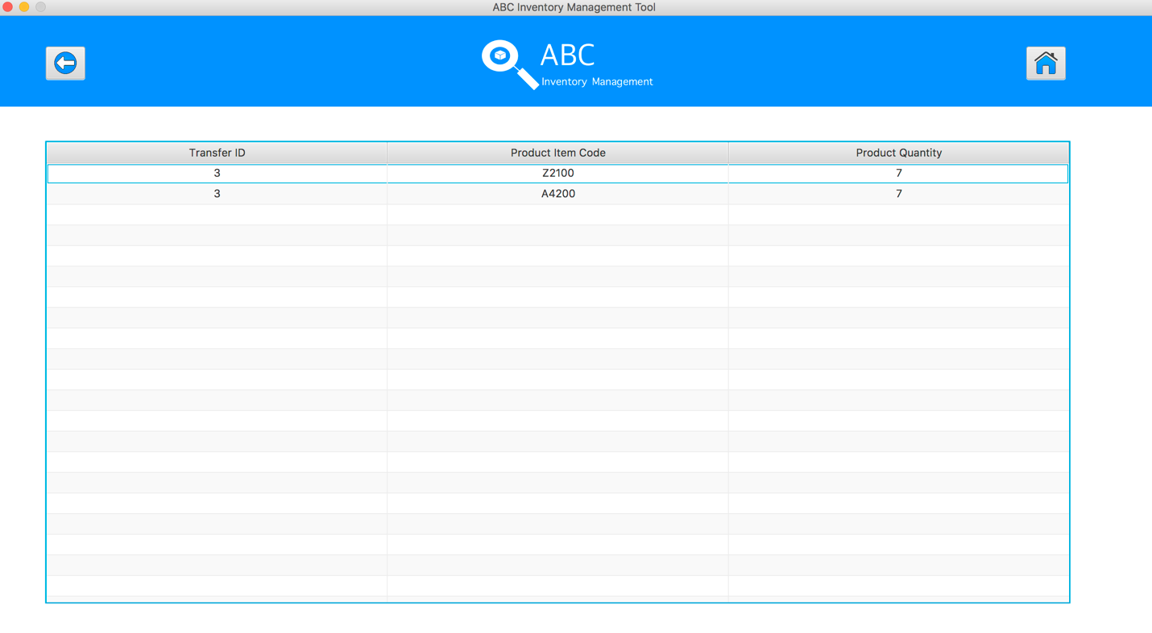

**GRP003- Test Use Time Filter For Searching Report** **for Data Set 1: PASS**

## Data Set 2

|  |  |
| --- | --- |
| **Test Data Table** | |
| **transferID** | 3 |
| **From Date** | N/a |
| **To Date** | 31/05/2018 |

#### Result Screenshots

The screenshots of the result on each test step for each data set are given below:

**Step 1**

Open the Generate Report Page

**Step 2**

Input To Date then hit search button to display the transfer from the past until the selected To Date

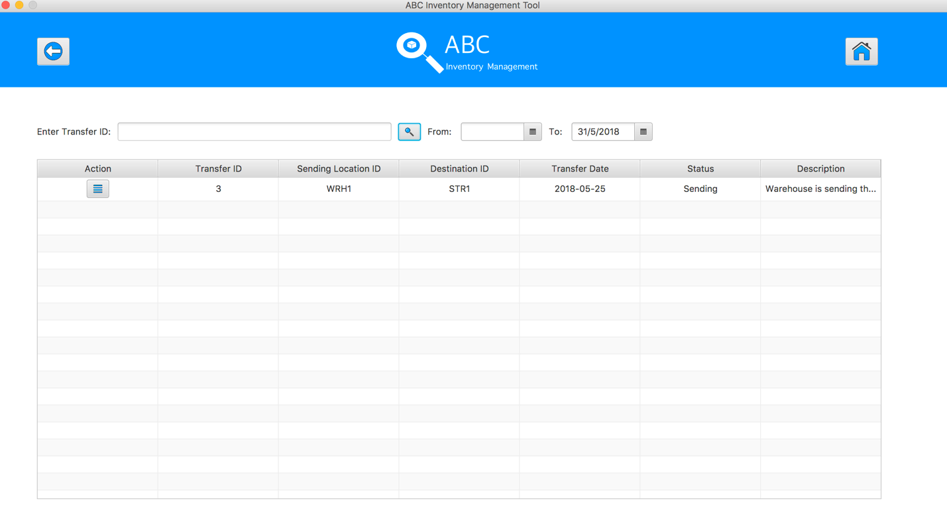

**Step 3**

Hit the ‘View the product in this transfer’ button to view the products and their quantity in this transfer.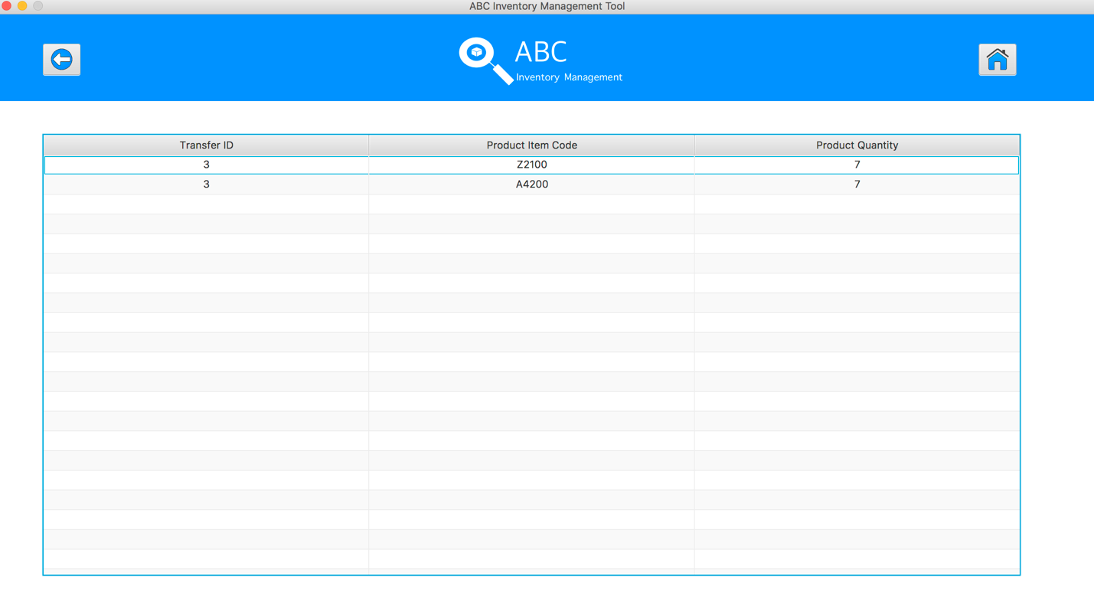

**GRP003- Test Use Time Filter For Searching Report** **for Data Set 2: PASS**

## Data Set 3

|  |  |
| --- | --- |
| **Test Data Table** | |
| **transferID** | 1 |
| **From Date** | N/a |
| **To Date** | 31/05/2018 |

#### Result Screenshots

The screenshots of the result on each test step for each data set are given below:

**Step 1**

Open the Generate Report Page

**Step 2**

Input From Date then hit search button to display the transfer from the selected From Date until current time

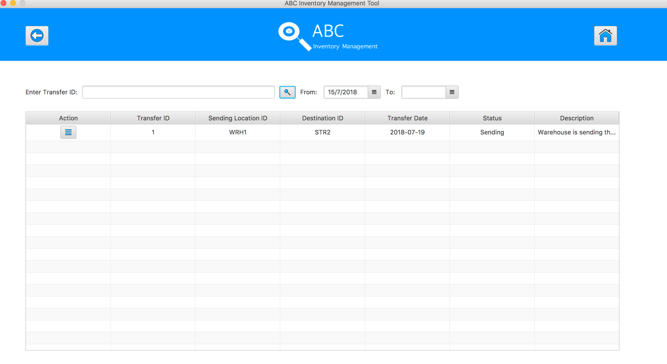

**Step 4**

Hit the ‘View the product in this transfer’ button to view the products and their quantity in this transfer.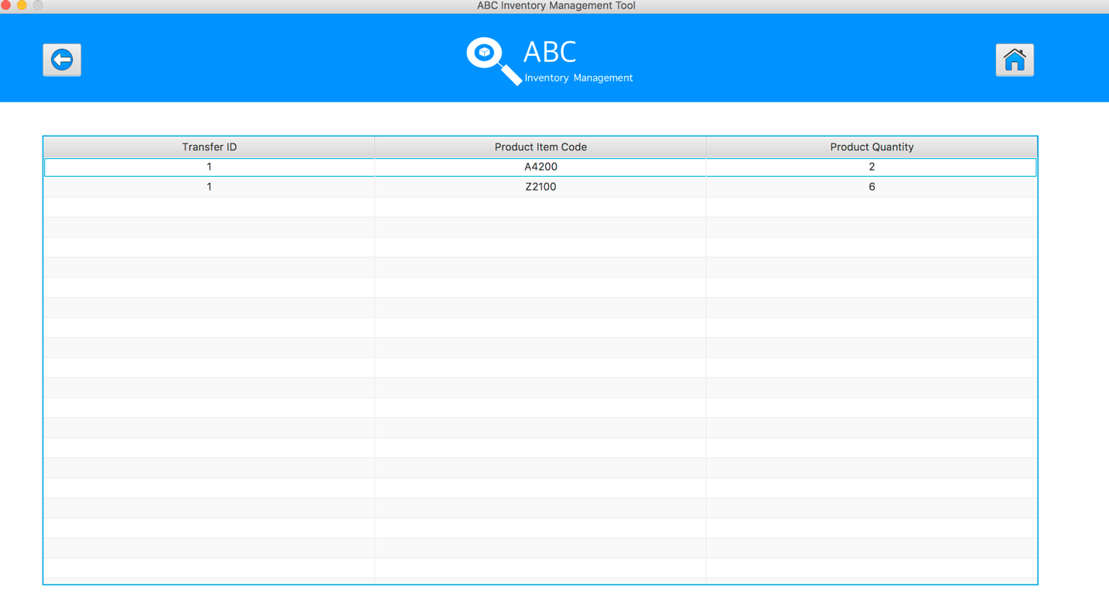

**GRP003- Test Use Time Filter For Searching Report** **for Data Set 3: PASS**